MILESTONE 3
Bădică Ioana-Miruna, 1241EA

1) Monolithic architecture
A monolith contains all features in one deployable application (Spring Boot). For Heart of Bucharest that means:
- Modules within one app:
  - Presentation / API (REST controllers used by the frontend/mobile).
  - User module (customers, admins, profile, login).
  - Event module (create/list events, capacity).
  - Booking module (bookings, capacity checks).
  - Notification module (email/push).
  - Reward module (strategy-based reward computations).
  - Persistence layer (single relational DB with tables for users, events, bookings).
- Interactions: Controllers call service layer → repositories. When an event is created, the EventService calls NotificationService directly (method call). When a booking is created, BookingService calls RewardService and updates the user in the same DB transaction.
- Data flow: Client → API Controller → Service → Repository → DB. Notification and rewards happen synchronously (or via in-process scheduled tasks).
This approach is simplest for implementing and demonstrating the required design patterns in a single codebase.
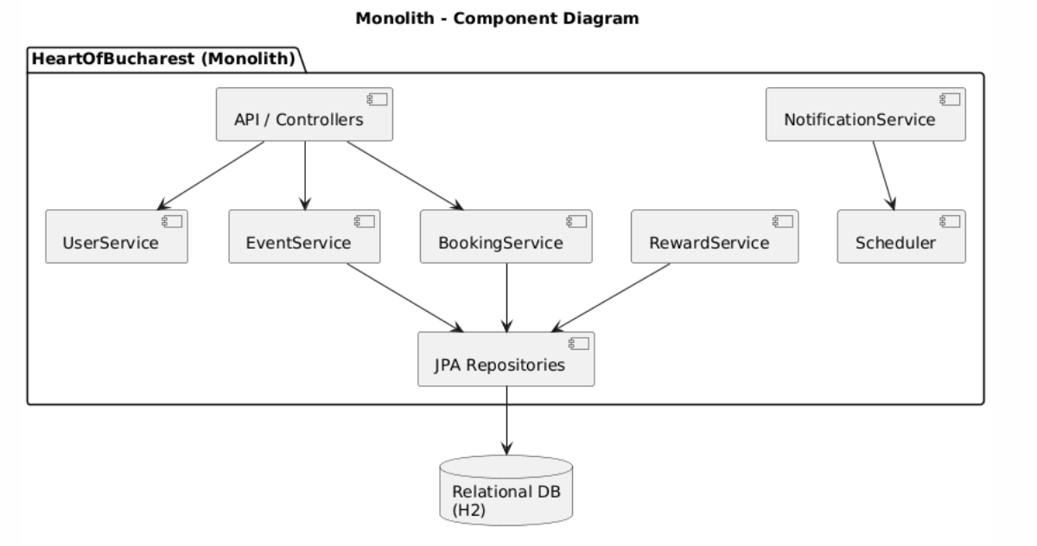
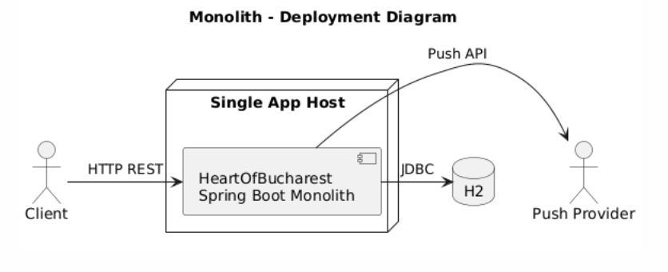

Pros
- Fast to implement — good for graded projects and POC; fewer moving parts.
- Simple local dev & debugging — one process, no network trace complexity.
- Transactional simplicity — booking + user updates are ACID within single DB.
- Lower infra/operational burden — one server, no message broker required.
- Good for demonstrating design patterns inside one codebase.

Cons
- Scaling inefficiency — you must scale whole app even if only notifications need throughput.
- Deployment risk — any change requires full redeploy.
- Tight coupling — harder to evolve independently (e.g., separate team working on notifications).
- Long-term maintainability — as features grow, module boundaries become brittle.

2) Microservices architecture - best for this project
Divide functionality into separately deployable services, each with its own DB (database-per-service) where appropriate. For my applications, these services might be most useful:
- API Gateway (Edge) — single entry for clients, routing, auth (optionally rate-limiting/caching).
- User Service — user registration/login/profile; stores users and reward points.
- Event Service — create/list events, event details (owns events DB).
- Booking Service — book/unbook events, confirm capacity (owns bookings DB). When booking, it queries Event Service for capacity (synchronous) or uses eventual-consistent reservation pattern (async). After booking it publishes BookingCreated.
- Notification Service — consumes EventCreated and BookingCreated messages to send emails/push.
- Reward Service — consumes BookingCreated (or AttendanceConfirmed) and applies a RewardStrategy (multiple implementations available) — updates User Service via a REST call or publishes UserPointsUpdated.
- Message Broker (RabbitMQ or Kafka) — used for events (Observer). Use asynchronous messages for notifications and reward work; synchronous REST for strongly consistent queries where needed (e.g., capacity check or user validation).
- Service Discovery / Config / Monitoring — optional (Eureka/Consul, Config Server, Prometheus/Grafana).
Data flow examples:
- Create event: Client → API Gateway → Event Service (save) → Event Service publishes EventCreated → Notification Service consumes and emails subscribers.
- Book event: Client → API Gateway → Booking Service → (sync) BookingService checks EventService for capacity → BookingService saves booking → BookingService publishes BookingCreated → Reward Service consumes and updates user points via User Service.
I will use RabbitMQ to keep synchronous REST calls only where immediate consistency is required.
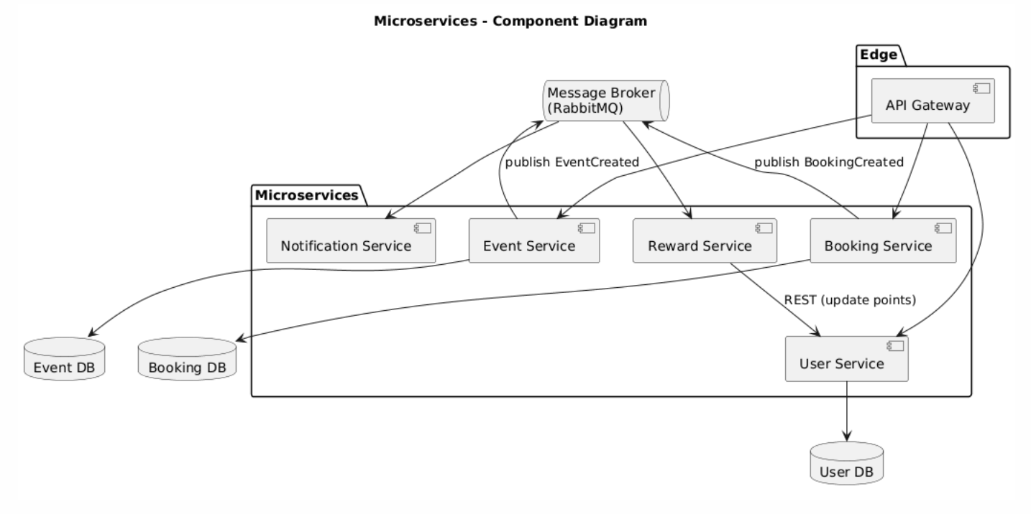
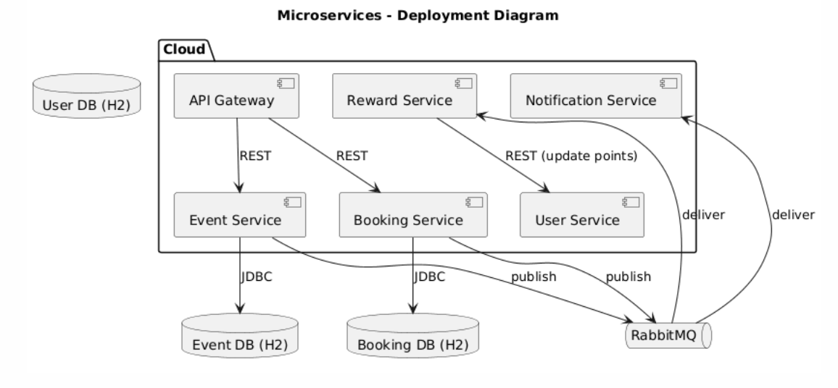

Pros
- Independent scaling & deployment: Notification Service can scale separately during campaigns; Booking Service scales on peak sign-ups.
- Loose coupling & code ownership: Teams (or you moving to multiple modules) can develop features independently; each service has clear responsibility.
- Resilience: failures isolated; e.g., Notification outage does not stop bookings.
- Extensibility: new consumers (analytics, search) can subscribe to event streams without changing producers.
- Technology choice: you can use specialized tools (e.g., Node for notifications, Java for core services) if needed.
- Clear demonstration of patterns: Observer (message broker), Strategy (Reward Service), Builder (entity construction) map well to separate services — great for coursework.

Cons
- Operational complexity: need CI/CD pipelines for each service, container registry, service discovery, monitoring, logging (ELK/Prometheus). This is overhead for a student project.
- Distributed complexity: distributed transactions require sagas or compensation; capacity checks demand careful design (optimistic reservation or pre-reservation with timeouts).
- Testing complexity: integration testing across services & broker is heavier — you must set up test harnesses or use contract testing.
- Cost & time: more infra and development time than monolith; but aligns with your requirement to implement microservices.

3) Event-Driven distributed architecture (EDA)
This is a different distributed style from microservices, focusing on asynchronous events as the first-class mechanism. It can look similar to microservices but emphasizes event stores and streaming.
In an Event-Driven Architecture the system is organized around events and streams:
- Producers: Event Service (publishes EventCreated), Booking Service (publishes BookingCreated), User Service (publishes UserUpdated).
- Event Broker / Event Store: Kafka (topic-per-event type) is central — durable, ordered event log.
- Consumers: Notification Service, Reward Service, Analytics, Search indexer — they react to streams.
- Materialized views / read models: Separate components (or services) build query-optimized databases from event streams (e.g., an EventsReadModel for fast querying).
- Command side: Commands (create booking) can be forwarded to command handlers which publish events when completed.
- Data flow: client issues commands → command handler validates & publishes events → events are appended to the event log → consumers react and update their local state/read models.
This style treats events as the source of truth (event sourcing optionally) and provides excellent decoupling.
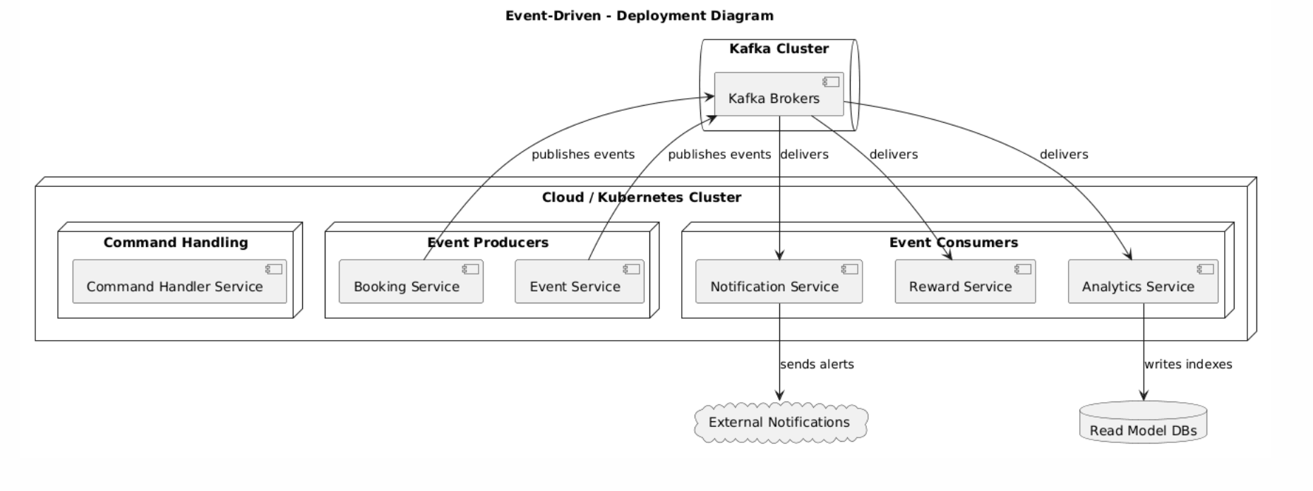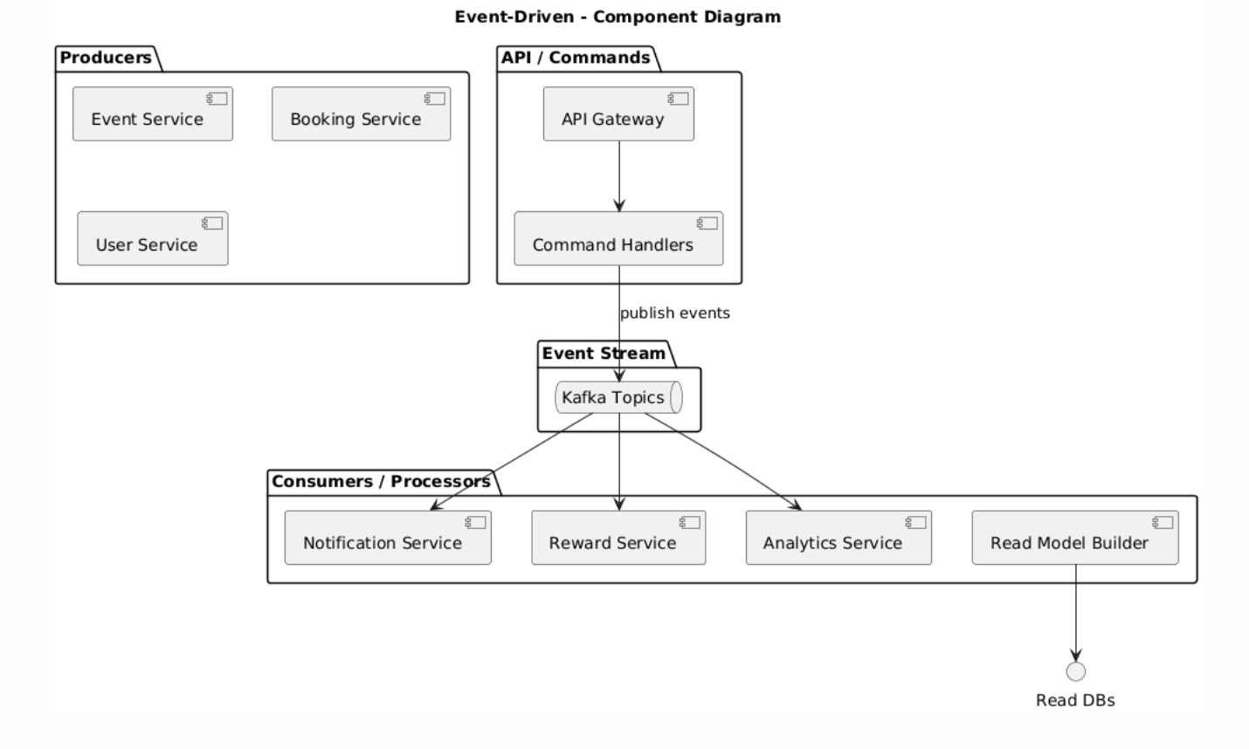

Pros
- Extreme decoupling & extensibility: new analytic or notification consumers can be added without touching producers — very good for future features (search, recommendations).
- High throughput & replayability: Kafka provides durable logs and ability to rebuild read models — useful for analytics about volunteering patterns.
- Natural fit for asynchronous tasks: email campaigns, recommendation pipelines, and offline analytics are elegantly supported.
- Audit & history: event logs provide complete history (valuable for later research/analysis).

Cons
- Steep learning curve & infra needs: Kafka clusters, schema registry (Avro/Protobuf), retention policies — more overhead than simple microservices with RabbitMQ.
- Eventual consistency & UX complexity: you must design UI feedback for asynchronous state (e.g., booking pending until confirmed).
- Complex testing and debugging: tracing an event across topics requires good observability tooling.
- Possibly overkill for a course project unless you need heavy analytics or replay features.

Comparison
Aspect | Monolith | Microservices | Event-Driven
Implementation speed (POC) | High | Medium | Low
Operational complexity | Low | Medium–High | High
Scalability | Low | High | Very high
Extensibility | Medium | High | Very high
Transactional simplicity | High | Medium (sagas) | Low (sagas/events)
Observability difficulty | Low | Medium | High
Suitability for course graded project | High | High (if required) | Medium–Low (unless analytics focus)

Which is best for my project and why
For my project, Microservices architecture is the most suitable choice because:
- Matches assignment requirement: I must implement microservices — so pick an approach that is practical to implement within time and demonstrates architectural concepts.
- Balanced complexity: Microservices give separation and scalability without the full complexity of an event-sourcing Kafka ecosystem. RabbitMQ + Spring Boot microservices gives a manageable learning curve.
- Good mapping to domain: Each domain area (Users, Events, Bookings, Notifications, Rewards) becomes a natural independent service. This maps to the course requirement to showcase design patterns across services (Observer via broker, Strategy in Reward Service, Builder in Event/Booking models).
- Incremental delivery: you can start with a small set of services (User, Event, Booking, Notification, Reward) and expand; you can run locally with docker-compose + RabbitMQ (I provided a starter earlier).
- Academic depth & industry relevance: Microservices let you demonstrate distributed design, inter-service communication patterns, and trade-offs (sagas, eventual consistency) — strong material for the report & evaluation.

